PhotoVis 1.0 User Manual

This is the official guide to PhotoVis. PhotoVis is intended as an image browsing software designed for handling grouped assignments and projects.

# MIT License

Copyright (c) 2019 VA Visjon AS

Permission is hereby granted, free of charge, to any person obtaining a copy of this software and associated documentation files (the "Software"), to deal in the Software without restriction, including without limitation the rights to use, copy, modify, merge, publish, distribute, sublicense, and/or sell copies of the Software, and to permit persons to whom the Software is furnished to do so, subject to the following conditions:

The above copyright notice and this permission notice shall be included in all copies or substantial portions of the Software.

THE SOFTWARE IS PROVIDED "AS IS", WITHOUT WARRANTY OF ANY KIND, EXPRESS OR IMPLIED, INCLUDING BUT NOT LIMITED TO THE WARRANTIES OF MERCHANTABILITY, FITNESS FOR A PARTICULAR PURPOSE AND NONINFRINGEMENT. IN NO EVENT SHALL THE AUTHORS OR COPYRIGHT HOLDERS BE LIABLE FOR ANY CLAIM, DAMAGES OR OTHER LIABILITY, WHETHER IN AN ACTION OF CONTRACT, TORT OR OTHERWISE, ARISING FROM, OUT OF OR IN CONNECTION WITH THE SOFTWARE OR THE USE OR OTHER DEALINGS IN THE SOFTWARE.

# Getting started

To get started you first must create a new project. This is a container that lets you organize your images on a per-project basis. Upon the first run you will face this screen:

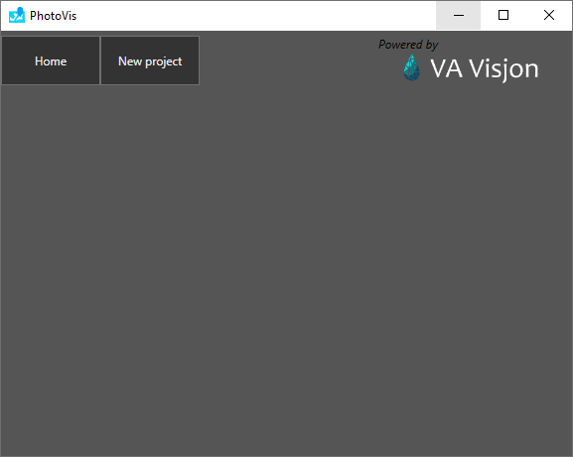

1. Click the “New project” to get started with your first project. This will open up the following menu and allow you to get started.

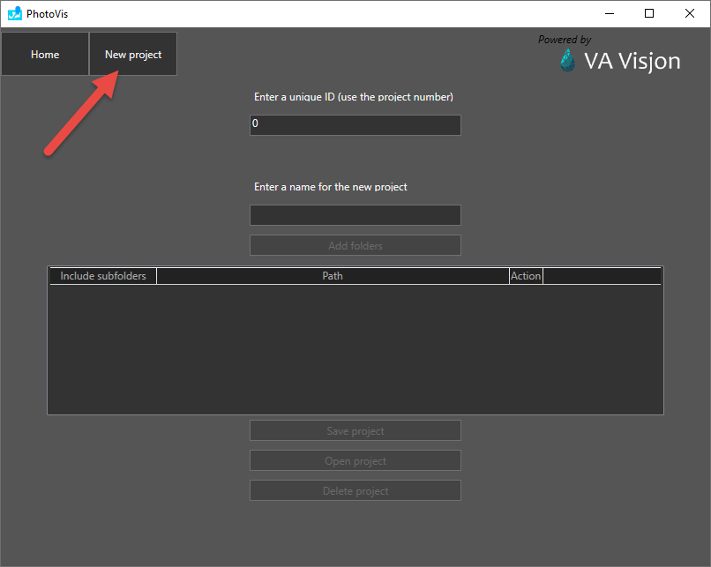

1. Set a unique project number ID, and give it a sensible name. Add the folders you want to include in this project. You may choose a root folder and include its subdirectories, or you may pick single folders. This is up to you.

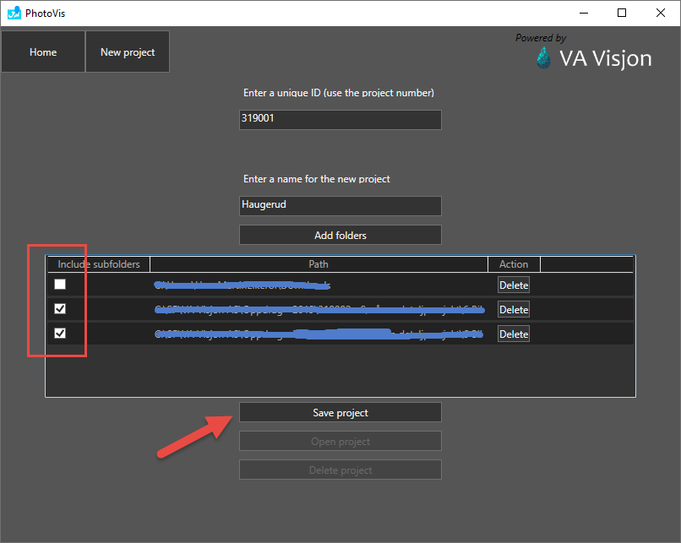

1. Save the project. Open the project. This will initialize the first run and the program will index all the folders you have submitted in the manner you chose. If your photos reside on a cloud platform (ie. Sharpoint, OneDrive or similar) the software will have to download the images in the folders to your local drive in order to analyze them.

Depending on the size of the project and the number of photos, you may have to navigate away from the map view, back to project view, then go into the map view again in order to display all images properly.

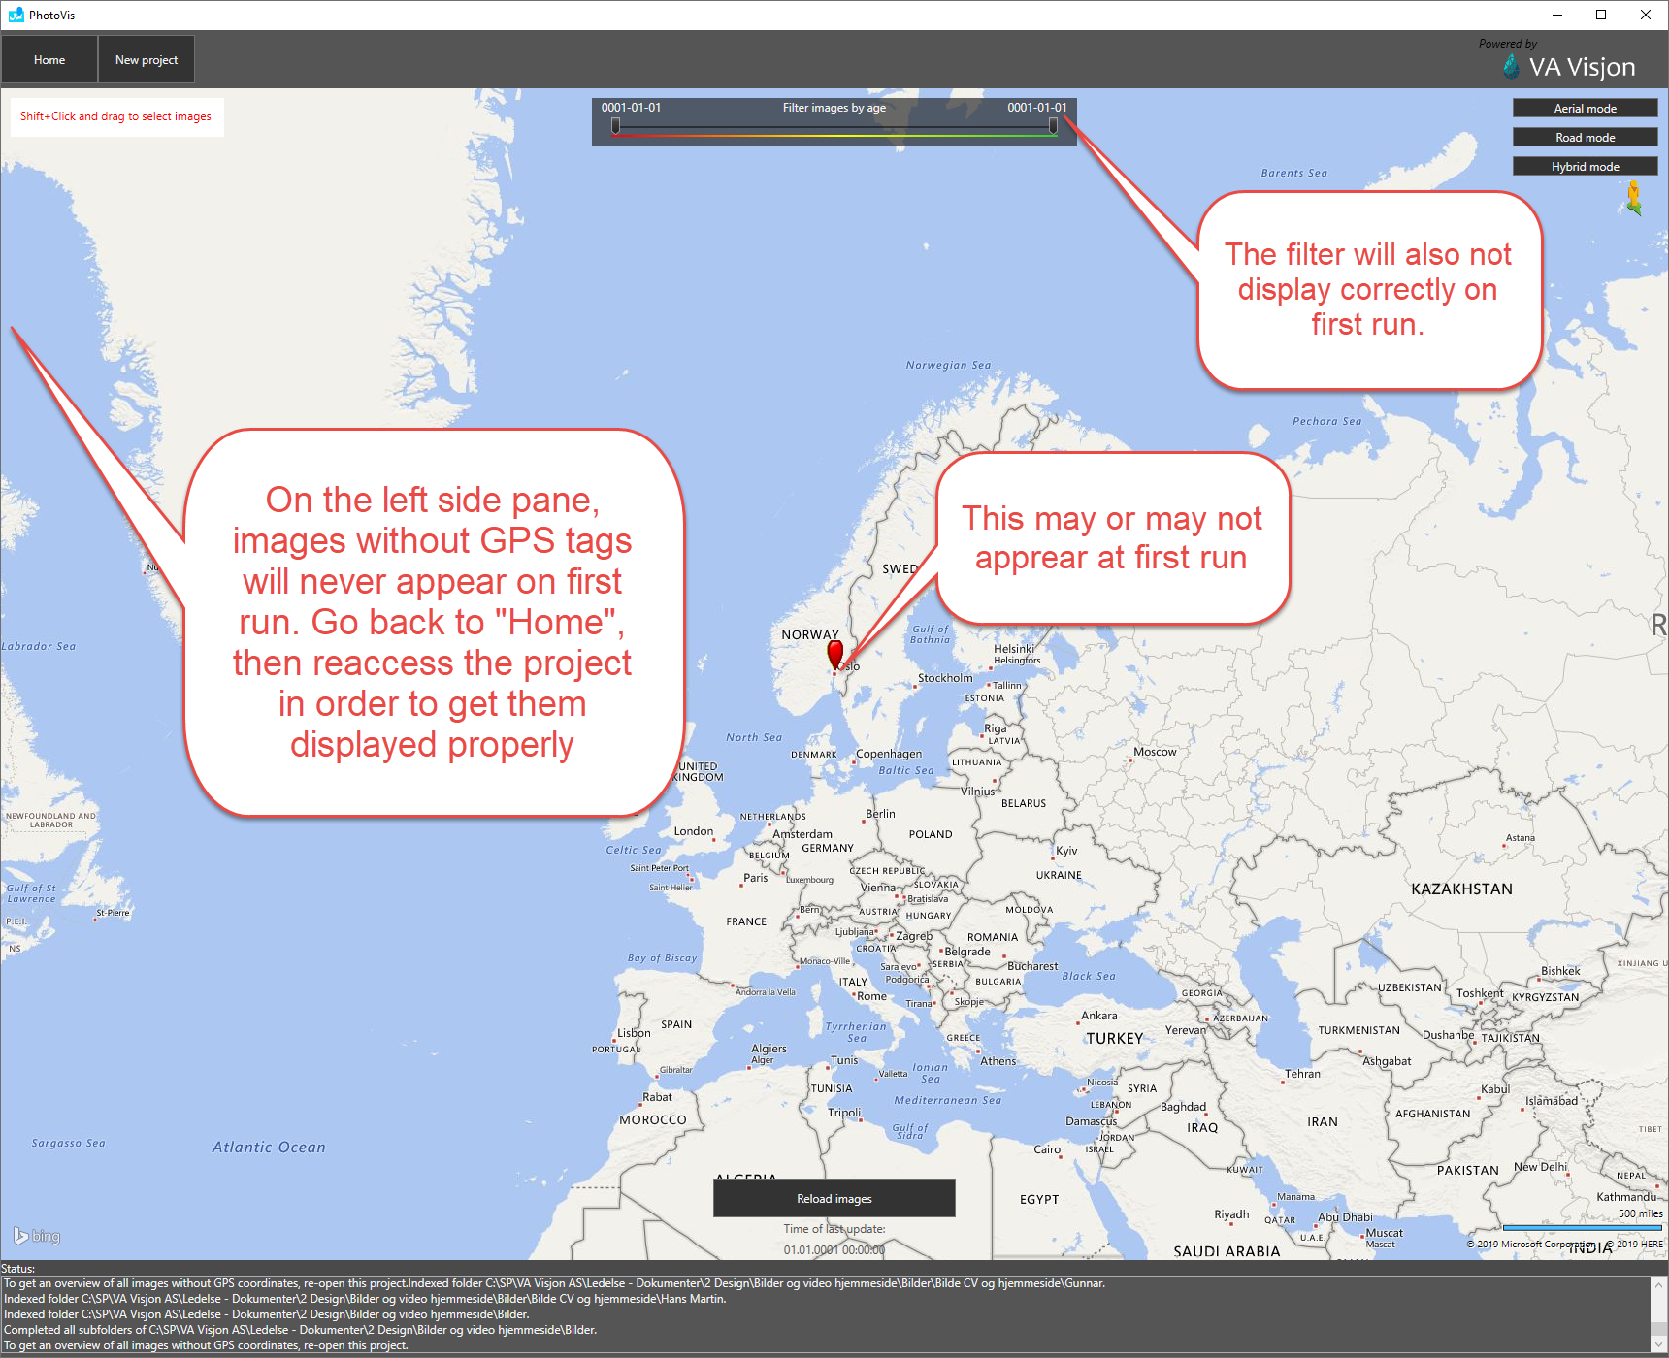

To properly fix any display issues, simply navigate back to “Home”, then reopen the created project.

1. Upon first run, you will see the following message on the map:



This is because the software does not come with a Bing map paid service. In order to get rid of this message, you can create your own developer account (one time) with Bing, and create an API key for Bing maps. Click the Bing maps key link in the header menu:

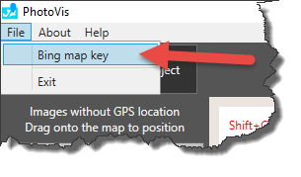

This will open the following window:

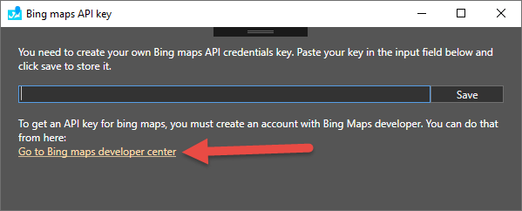

Click the link to get to Bing maps developer center.

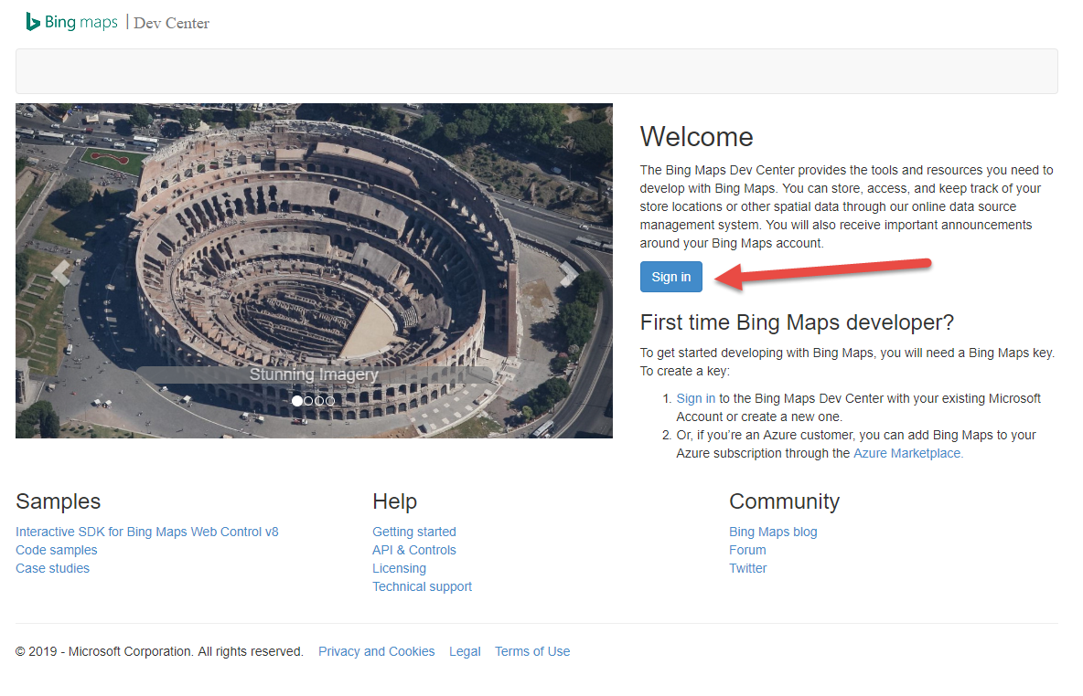

Then sign in with your own personal Microsoft account. Once signed in, go to “My account” then “My keys”.

Create a new key which you name eg. PhotoVis. Copy the key to your clipboard.

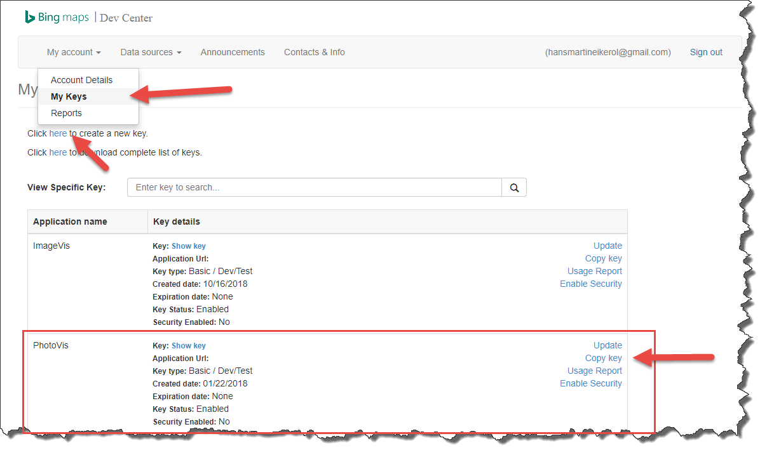

Paste the key into the Bing maps API key dialog inside PhotoVis. Click “Save”, and you’re good to go.

1. Click the “Home” button. You should see something like this:

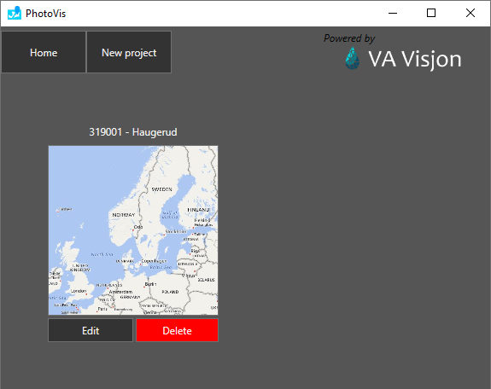

Then click the image to access the project again. Everything should now display correctly.

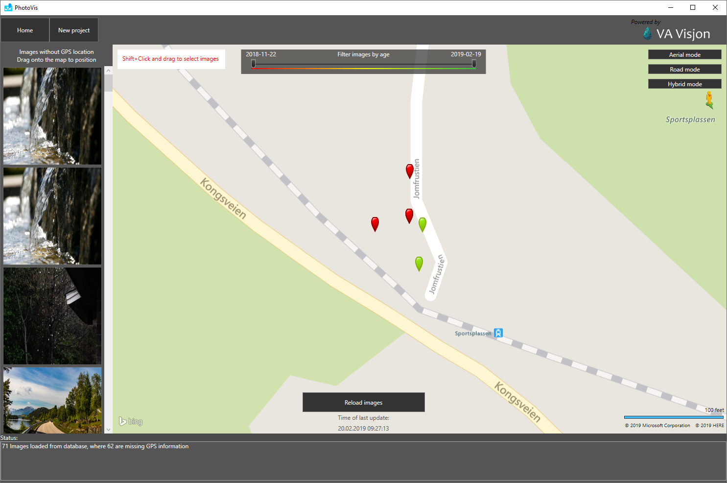

1. With everything now displaying correctly, you are ready to browse the images with GPS-data. To display images from a certain area, hold the Shift-key and click and drag your mouse over the area you need. Dragging in any direction is allowed.

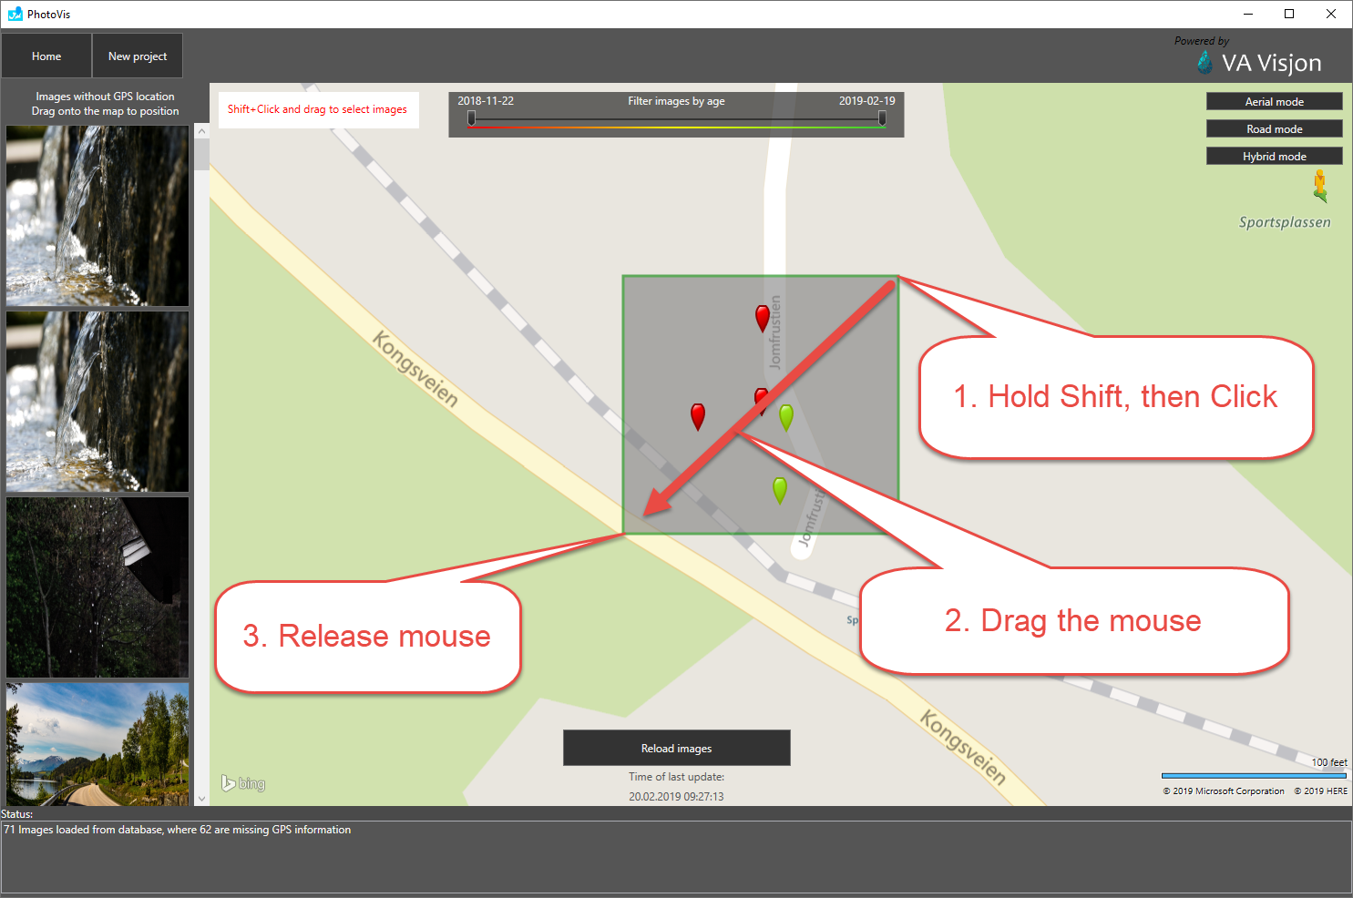

1. After selecting images, an image browser overlay will appear. Inside this window you can use keyboard arrow keys to navigate to previous/next image, and use Esc to return to the map view.

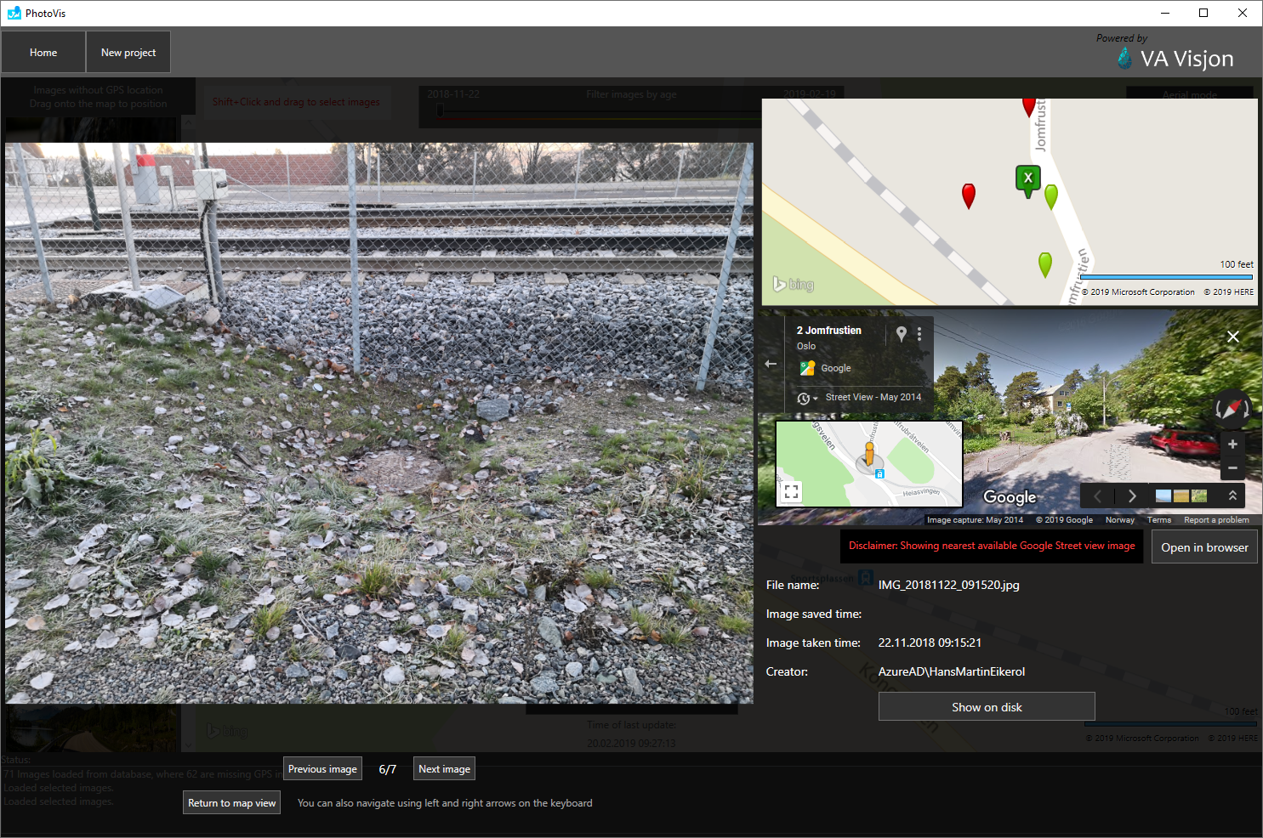

Inside the image browser view, a small map in the upper right corner will show you which of the selected photos you are currently viewing (marked by an X). The **nearest available** Google Street View imagery will appear in an embedded browser window in the middle right. At lower right you can see some of the information about the file. There’s also an option to view the file in your file system.

# Filtering

We support filtering of images by their time taken timestamp. Some images will not have such a timestamp. For them we use the time saved timestamp (hence, we do not want to manipulate original images).

Filtering is done by dragging the sliders at the top. The slider will always display the range from red to green going from the eldest image to the most recent.

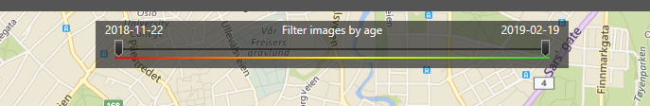

# What about files that does not have GPS-information?

Some imagery may not have GPS-information attached to them, so there is an option to place such images onto the map where you know the originate from. See the image below.

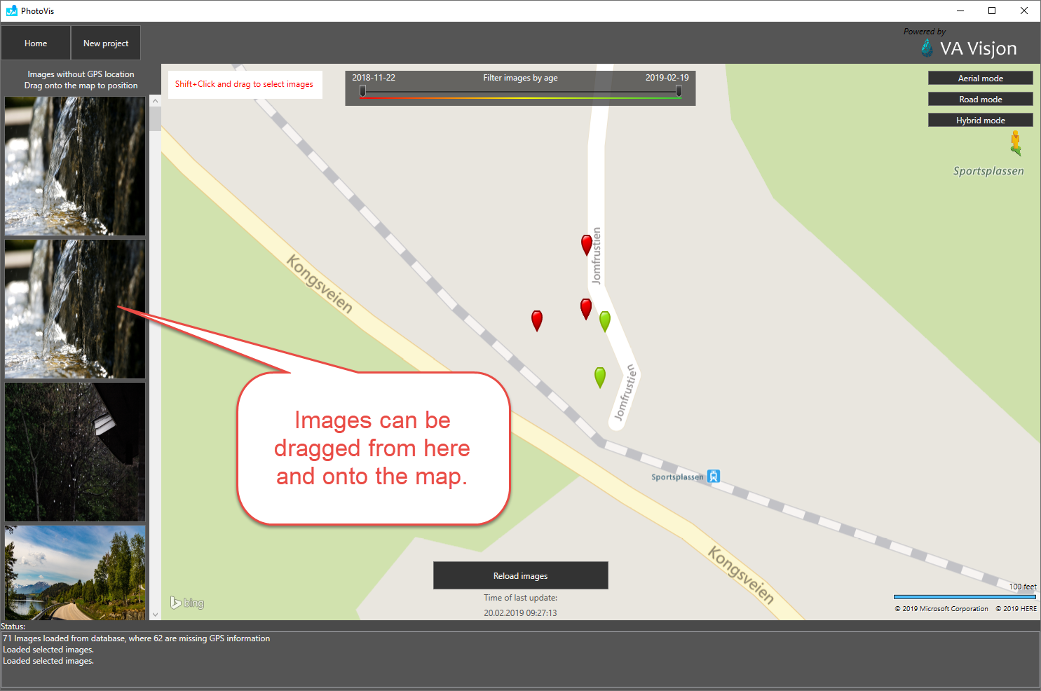

Dragging an image from the left pane onto the map immediately removes the image from your left pane, and places it on the map.

Since PhotoVis tries to minimize its impact on your files and folders, we do not add the new GPS data to the original image or manipulate it in any way. Instead, we create a new file with the same name as the image, but with the extension “koo” (short for coordinate). In your file structure, it will look like this:

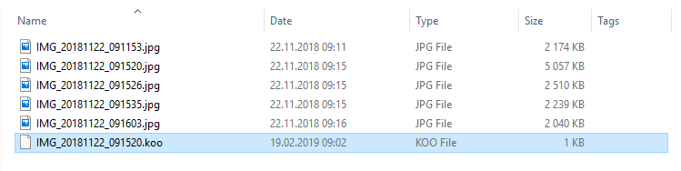

We do this since all the indexing of imagery happens on your local computer. Projects you create are for you and you alone. If your colleague wants to index the same or similar projects, he needs to configure that for himself.

However, if you place non-GPS imagery onto the map and create “.koo”-files for non-tagged imagery, your colleague will also get those images positioned correctly as you placed them. Thus the need for .koo-files.

# Supported file formats

Only JPEG files are currently supported.

# Behind the scenes

All the indexing and managing of imagery is stored in folders at the location:

C:\Users\<You>\AppData\Roaming\PhotoVis

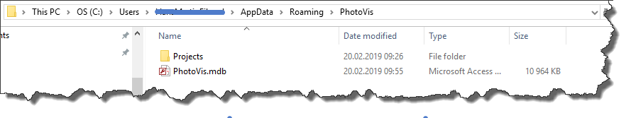

This is by default a hidden folder, so unless you type in the address directly in the file explorer, you wont be able to see the location. Or you may enable viewing of hidden files and folders on your computer through the File Explorer Options on Windows. Type in eg. “Folder options” in the Windows application menu.

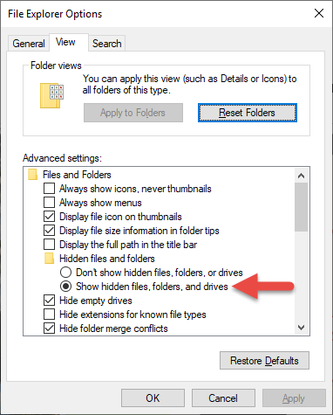

All indexing work is stored in a Microsoft Access database called PhotoVis.mdb on your local computer.

# FAQ

**Is it possible to change the location of an image?**

* Currently no. We may add this feature in the future.

**I misplaced an image without GPS data in it. How do reset it to place it anew?**

* You must first delete the corresponding .koo-file. Your local database will still remember its placed location, so you can do one of the following:
  + Open the PhotoVis.mdb database in Microsoft Access and edit the record of that image by wiping the stored latitude and longitude.
  + Delete the project, recreate it and index everything anew.